VPC network-2 with subnet-b

1. Once you first log in, your screen should look similar to this.

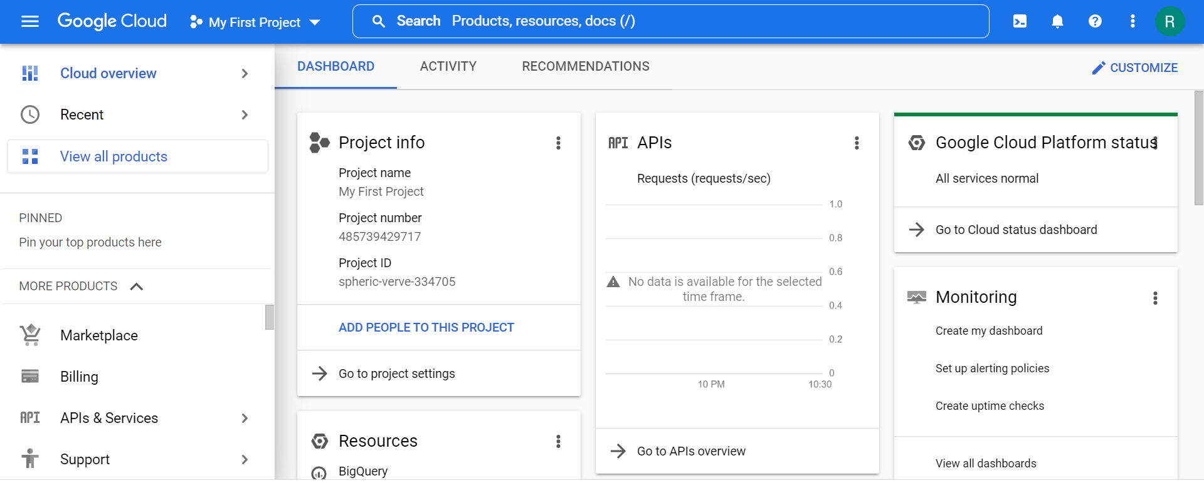

1. Click on the project selector drop-down menu at the top of the screen.

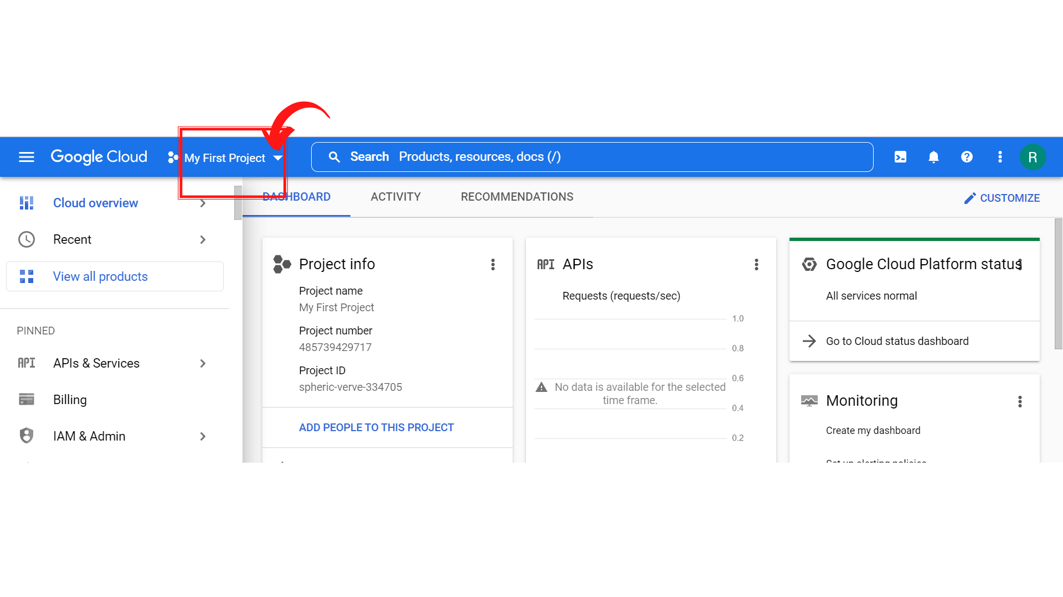

1. Since, we are doing labs on a Security Labs project, Click on *“Security Labs”*.

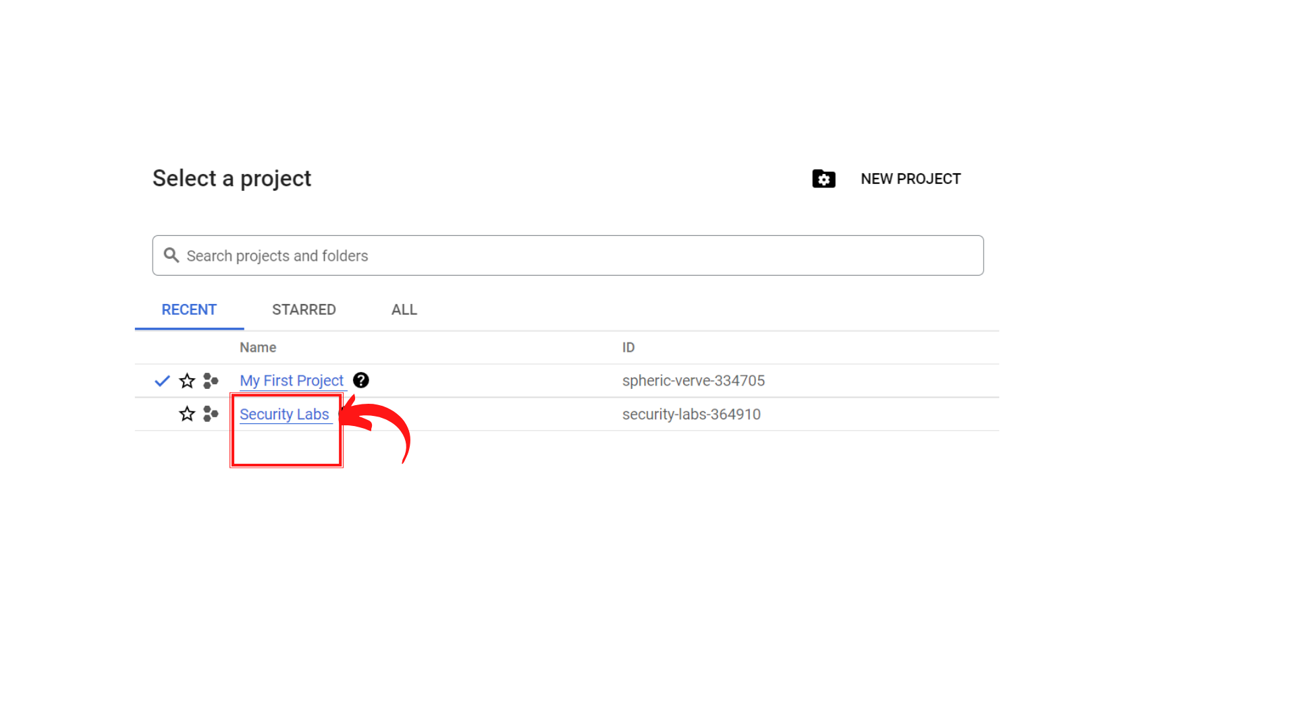

1. Your screen should look similar to this with project info changed to “*Security Labs”* project.

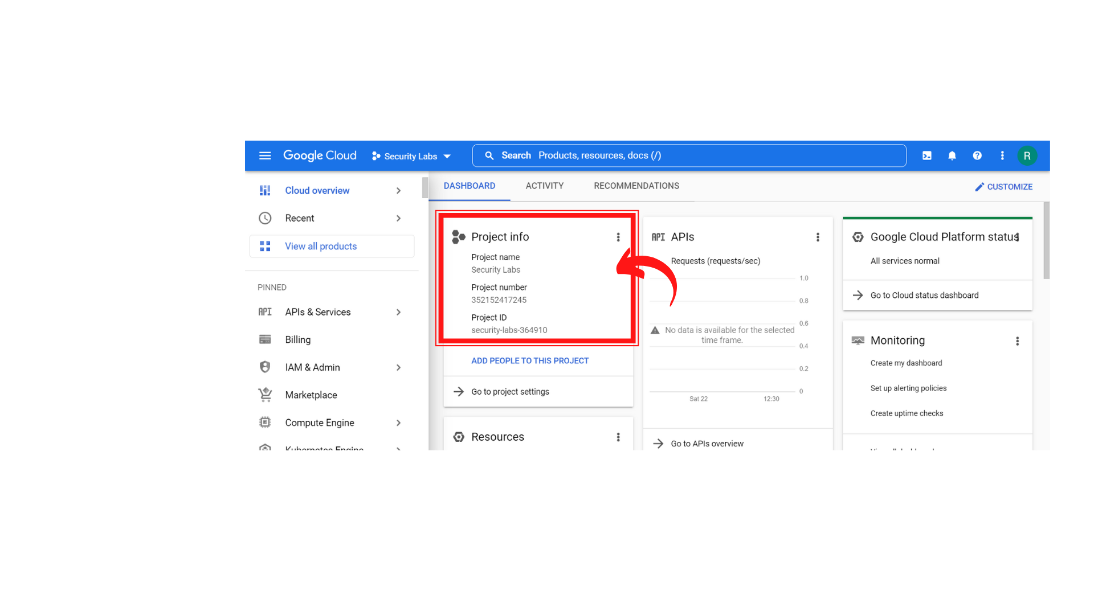

1. To create a new VPC Network, Click on *“Navigation menu”* on top left, then click on ***“VPC Network → VPC Networks”***

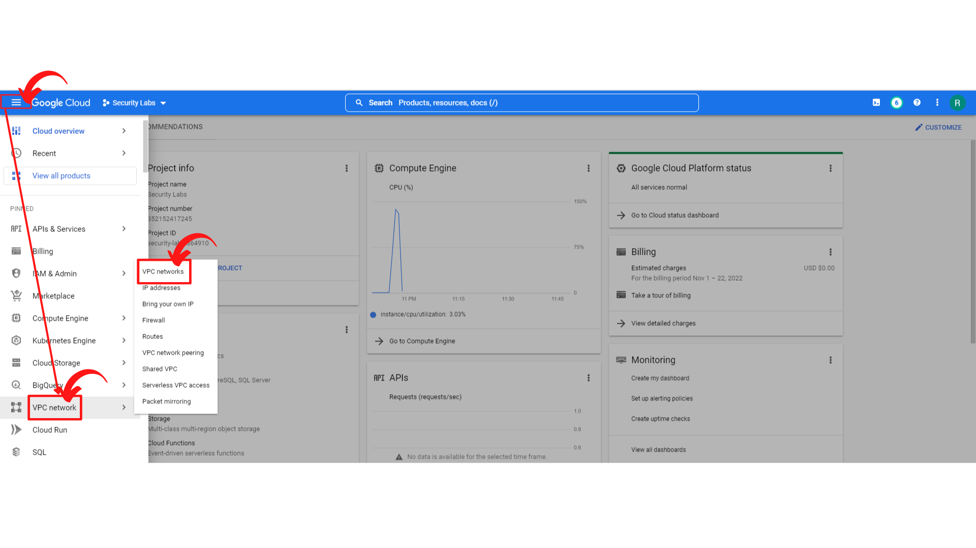

1. Your screen should look similar to this and *“Click → Create VPC Network”*

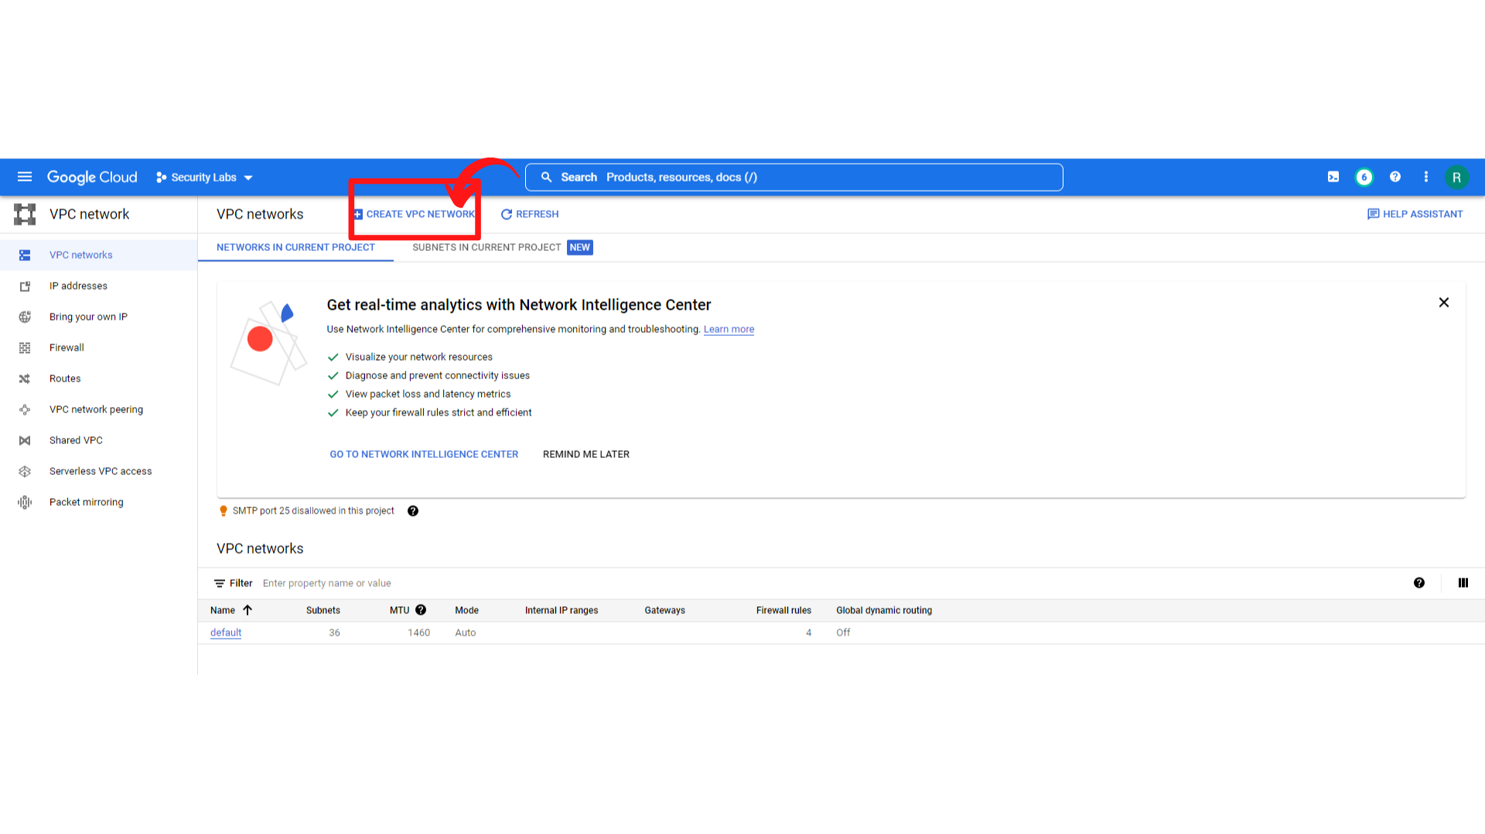

1. Your screen should look like this and ***Enter the Name→ network-2*** and ***Description*** of the VPC network.

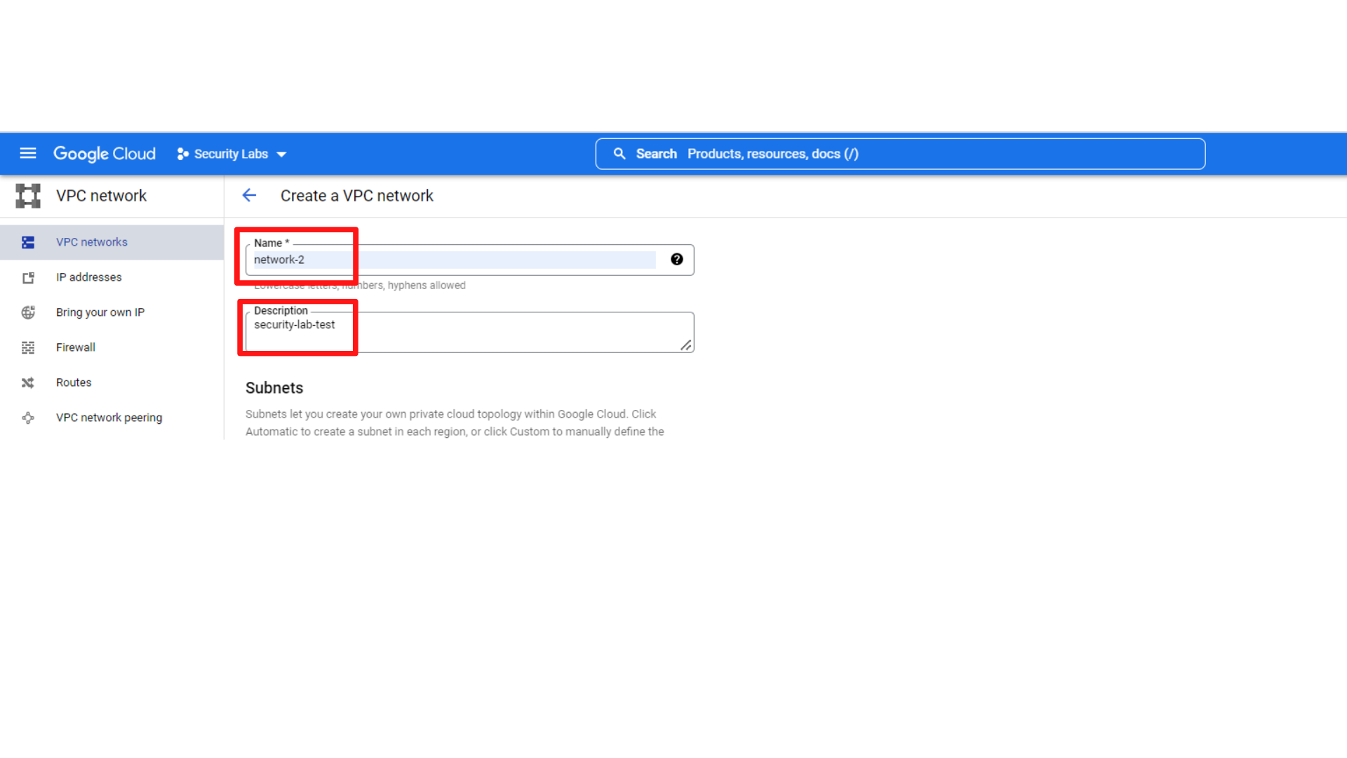

1. Now scroll down and select ***“Subnet creation mode → Custom”***

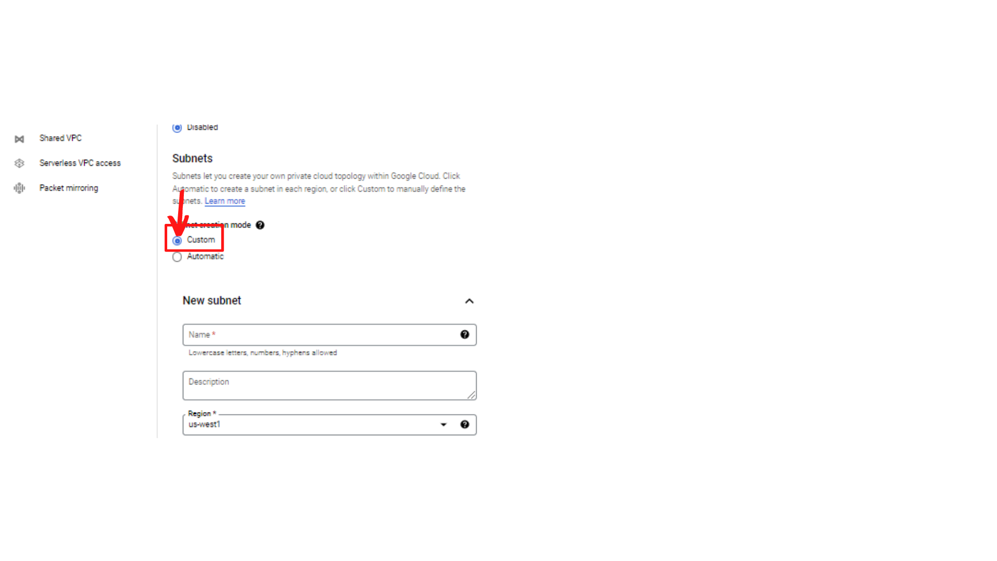

1. Now scroll down and you should see the ***“New Subnet”*** form.

Enter the following:

**Name :** ***subnet-b***

**Region :** select ***“us-west-2”***

**IP stack type :** ***IPv4 and IPv6 (dual-stack)***

**Enter IPv4 Range :** ***10.0.2.0/24***

***Leave all other setting as default***

Then ***“click → Done”***

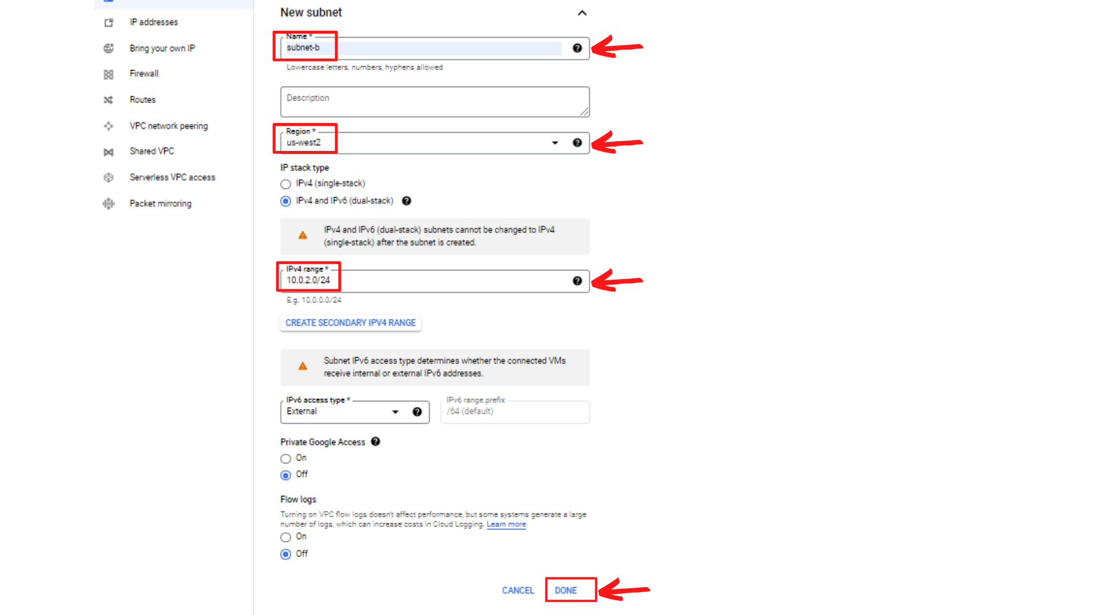

1. Now scroll down to see firewall rules section, In the ***Firewall rules section***, select zero or more predefined firewall rules. Here I'm not adding any Firewall rules.

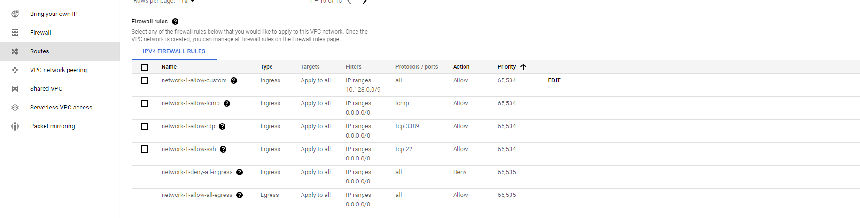

1. Now scroll down to see ***Dynamic routing mode and Maximum transmission unit (MTU)***, select the ***Dynamic routing mode as Regional*** for the VPC network and **set default MTU as 1460** and ***“Click → Create”***

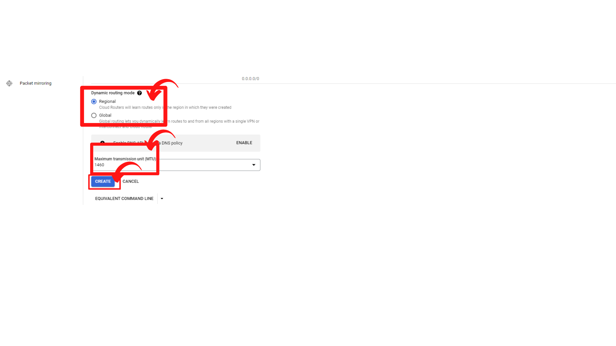

1. Your screen should look similar to this with the new VPC Network added with name network-2.

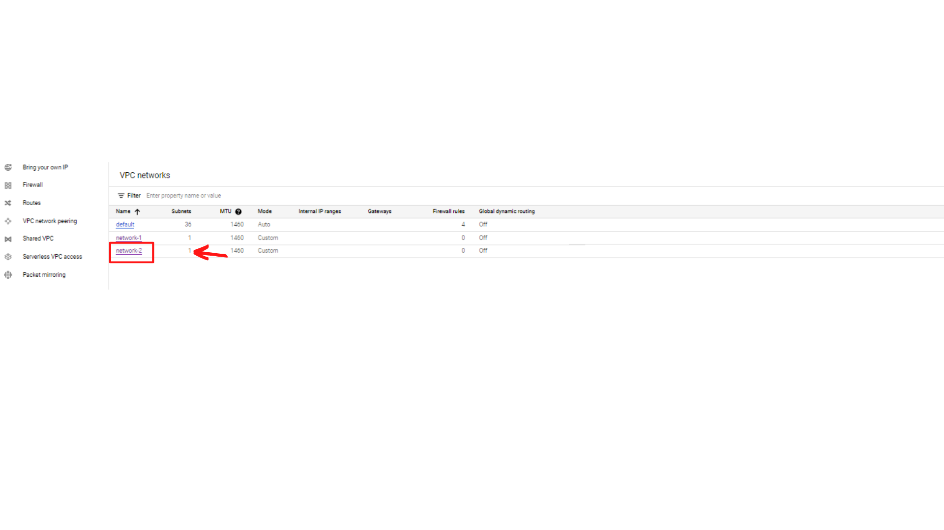

1. That’s it, you have successfully created a VPC Network with name network-2 with subnet-b.

